Covid-19 follows normal viral patterns and appears to ignore lockdowns, mask mandates, and other measures.

First, the politics.
As shown below and in the data from https://covidtracking.com, the virus has peaked or is just finishing peaking in all 50 states. This happens to be just as the vaccine is being put to use and a new administration entered the White House. There will surely be claims the vaccine and “New” strategy by the White House administration beat the Covid-19 battle. The data, some of which can still be displayed in a non-biased manner, will still show the truth.

- The following chart shows how viruses follow seasonality and latitudinal position.
This was discovered years ago by Robert Edgar Hope-Simpson as shown in the following chart:
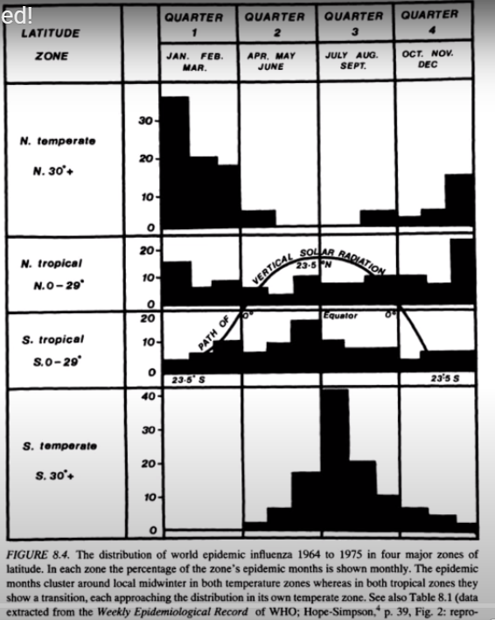
Figure 1: Season and Latitude effects

- Plotting the death rates (deaths per million) for a sample of 17 European countries shows this seasonality. In the following chart, each country had widely varying lock downs and mask mandates at widely varying times, yet the curves still follow the predictable pattern. Even Sweden which had no restrictions fits it with the rest. The area in the red circle is the summer months where the virus severity is drastically reduced, not my mitigation measures, but nature.
  - The first wave was less severe than it otherwise would have been only because it arrived too late for the fall/winter season, therefore herd immunity was not reached, and the virus resumed the next fall/winter.

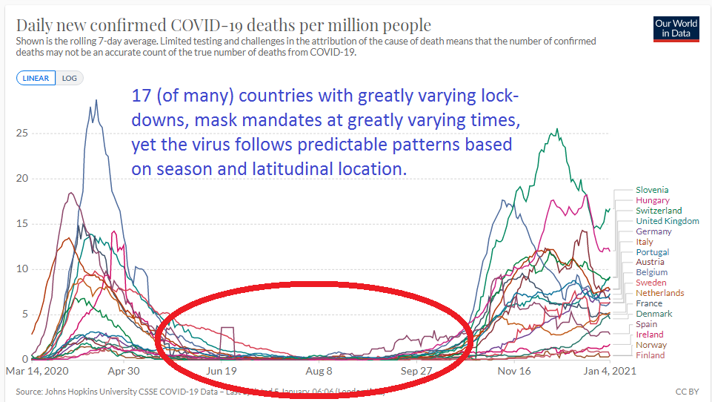
Figure 2: Death rates per million for 17 European countries.

- The USA curves by state also follow these patterns, however the USA spans a wide climate range, so the southern/warmer states lag as they are closer to the N tropical region as in Figure 1.

- If you draw a line from North Dakota straight south to Texas and look at the date where the peak hospitalizations occurred, it tracks in time from North to South, North Dakota peaking first.
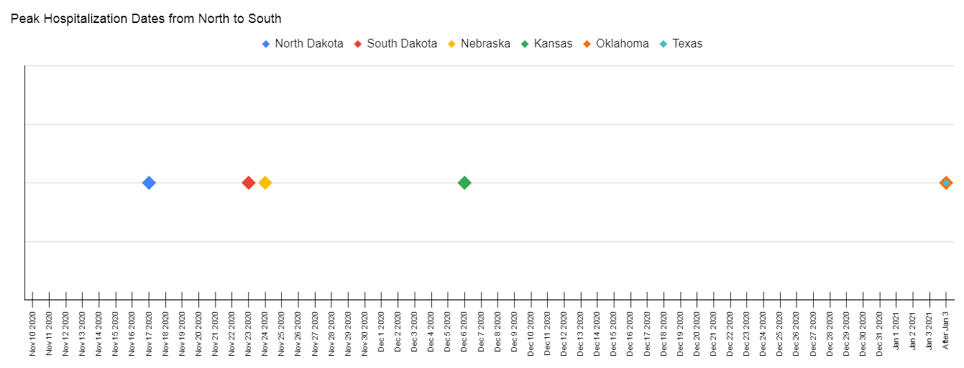
Figure 3: Peak Hospitalization dates from ND to TX. Note: TX and OK dates are still pending as the peaks have not occurred as of Jan 3.

- The following shows the states individual hospitalization rates. Looking at the most recent data (far right) of each curve helps show the trend of each state (source: https://covidtracking.com/):
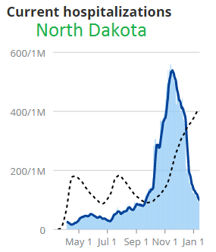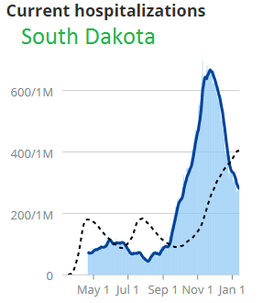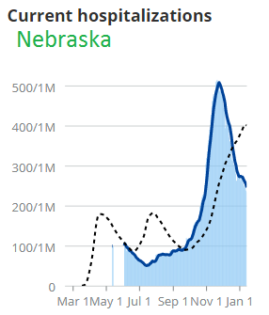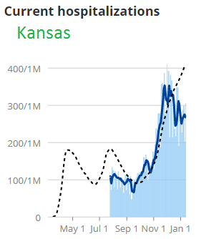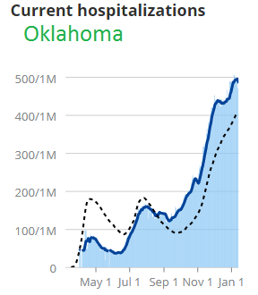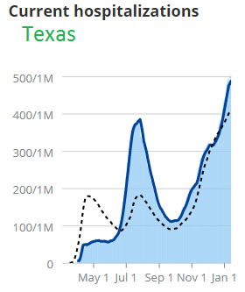

- It would take an extreme anomaly for any of the northern colder states which are far down from their fall/winter seasonal peak to increase in any significant amount before next fall. The trend should continue down. Next fall/winter should be a light or normal season based on historical data.

- The simple laws of nature also apply where anyone that does escape the virus, remains vulnerable until herd immunity is established by the virus itself or a vaccine. It seems this occurred in ND as well. We largely missed the first wave as the virus arrived, then as the fall winter arrived, those who didn’t escaped the first wave got it anyway.

- Cost to Benefit ratio. The cost is massive and includes the cost of lives in other areas to save lives.
From Scott Atlas: “We must open up because we’re killing people. In the US, 46% of the sis most common cancers were not diagnosed during the shutdown… These are people who will present to the hospital or their doctor with later stage disease – many of these people will die. 650,000 Americans are on chemotherapy – half of them didn’t come in for their chemo because they were afraid. Two-thirds of screening for cancer were not done. …. 200,000 cases plus of child abuse in the US during the 2 months of spring school closures were not reported because schools are the number one agency where abuse is noticed. We have one out of four American young adults, college age, who thought of killing themselves in the month of June..” (source link)

More detailed examples of countries mask mandate dates vs death rates. Due to lag from onset of symptoms to time of death, the expected change should be about 1 month after the mandate is implemented:
